Repeatability and Reproducibility Measures for different Metal Foil Length-based Electro-Mechanical Impedance Techniques: A Proof of Concept

Lukesh Parida 1, Sumedha Moharana 1*, Guilherme Ascensão3 , and Romeu Vicente4

**Abstract:** The PZT patches (Lead zirconate titanate) gained popularity as active aid to SHM for its dual sensing and cost effective. Besides the easy handling of PZT patches, due to complex geometry and non-accessibility of structural parts, a robust installation of PZT patch is always a great challenge. Again, for tubular structure, the curved surface does not allow the perfect bonding of PZT patches. To alleviate the above mentioned challenges, the non-bonded and reusable Configuration of sensor received considerable interest in the field of structural health monitoring over the past few However, ensuring the repeatability and reproducibility of EMI measurements is crucial to establish the reliability of these techniques. This study aims to study the repeatability and reproducibility measures for one of non-bonded Configuration of PZT patch i.e., Metal Foil Based Piezo Sensor (MFBPS). . This study discusses the concept and application, and suitability of Metal Foil Based Piezo Sensor (MFBPS) for impedance based monitoring technique of Civil infrastructure. Past literatures related to Metal Foil Based Piezo Sensor (MFBPS) have mentioned it practical application in EMI based application. This study evaluates the effect of length of Metal Foil Based Piezo Sensor (MFBPS) on piezo coupled admittance signature. Also, this study evaluates repeatability and reproducibility of EMI measurements via statistical tools such as ANOVA and Gage R&R analysis. The statistical index CCDM was used to quantify the deviations of impedance signals. The overall result shows that the repeatability of the EMI measurements improves with a metal foil length of 500mm. Overall, this investigation offers a useful point of reference for professionals and scholars to ensure the reliability of Metal Foil Based Piezo Sensor (MFBPS) for EMI techniques, a variant of piezoelectric sensor for structural health monitoring (SHM) applications.

**Keywords:** Structural Health Monitoring, R&R Study, Statistical Analysis, Electromechanical Impedance Techniques, Steel Rebar, Variance, Metal Foil Piezo Sensor, ANOVA.

**Introduction**

The field of structural health monitoring (SHM) has been gaining significant attention in recent years due to its potential to enhance the safety and reliability of various structures. The ability to continuously monitor the structural health of these systems provides critical information that can help prevent catastrophic failures and increase operational efficiency. The benefits of SHM extend beyond safety and reliability, as it can also help reduce maintenance costs and extend the lifespan of structures. By providing a better understanding of the structural behavior of a system, engineers can optimize maintenance schedules, reduce unnecessary inspections, and avoid costly repairs. In this era of aging infrastructure and increasing demand for safety and sustainability, SHM is becoming an indispensable tool for engineers, architects, and asset managers to ensure the safety and functionality of our built environment [1].

Among the various techniques developed so far for SHM, the Electro-Mechanical Impedance (EMI) techniques have emerged as a promising approach for SHM due to their non-destructive, low-cost, and real-time monitoring capabilities [2]. The method proposed by Bhalla and Soh [3] involves measuring the admittance of a PZT patch that is bonded or embedded in a structure, and then using a set of equations to extract the complex admittance signature. Equation 1 shows the admittance signature of the PZT patch.

 (1)

The EMI technique utilizes the inherent electrical properties of piezoelectric materials to monitor the mechanical impedance of a structure. The change in the impedance signature can be used to identify and locate damage, even at the very incipient level [4]. The EMI technique has been successfully demonstrated on a wide variety of engineered structures, including bridges, buildings, aircraft, and pipelines [5-7]. The non-destructive and non-invasive nature of the technique makes it particularly attractive for monitoring large and complex structures. Moreover, the low cost and ease of implementation of the EMI technique make it a practical solution for real-time monitoring of structures.

Although the EMI technique has shown promise for Structural Health Monitoring (SHM), there is still a need for additional research to address practical challenges associated with the method. One significant challenge is the brittleness of the PZT patch, which makes it challenging to attach the patch to structures with intricate geometry. If the component is consistently under impact or operated in a high-temperature environment, bonding the patch directly to the surface of the structure may not be possible. Additionally, detecting damage can be challenging for certain composite materials like concrete, as the conductance signature may not exhibit distinct peaks. Moreover, traditional direct bonded piezo configurations have certain limitations that can make them unsuitable for some applications. This has led to the development of non-bonded and reusable configurations that offer distinct advantages over direct bonded piezo configurations.

Non-bonded and reusable configurations offer distinct advantages over direct bonded piezo configurations in monitoring complex infrastructure systems. These configurations involve placing the piezoelectric sensor in contact with the structure being monitored using a non-permanent attachment method such as metal wire, magnets, clamps or adhesive tape [8,9]. This approach allows for quick and easy deployment of sensors and can be used in a wide range of applications. Furthermore, non-bonded configurations do not affect the mechanical properties of the structure, which helps to ensure the accuracy of the readings. Additionally, the non-bonded sensors can be removed and reused, making them a more cost-effective solution in the long term [10]. This allows for easy removal and repositioning of the sensor without damaging the structure or the sensor itself. Additionally, non-bonded sensors can be used multiple times, making them more cost-effective in the long run [11].

Na and Li [12] proposes a novel approach that utilizes a steel wire coupled with a PZT element to overcome the limitations of the EMI technique for composite structures with complex surfaces. The study conducted several tests to evaluate the effects of wire lengths, wire diameters, and PZT sizes on the impedance signature. Moreover, this study provides valuable insights into the application of the steel wire EMI method for the detection of damage, debonding, and deterioration of the adhesive layer in composite structures. The study showed that the method can effectively detect damage and differentiate between different damage scenarios. The authors also highlighted the potential of the method for real-time monitoring of structures, as it can detect damage at an early stage.

Naskar and Bhalla [13] present a novel approach for damage assessment of two-dimensional structures using metal-wire-based twin one-dimensional orthogonal array configuration of PZT patches. The authors highlight the importance of damage assessment in ensuring the safety and reliability of structural systems. However, the repeatability of the impedance signatures is a critical factor that affects the reliability of the monitoring systems. In this regard, the study related to the repeatability of the impedance signatures at a suitable metal wire length has not been adequately explored. Repeatability and reproducibility study is essential for ensuring the reliability and validity of suitable metal wire length based EMI techniques. Without these qualities, the technique may not be considered trustworthy or applicable in real-world situations.

Over the years, Measurement System Analysis (MSA) is an important statistical technique that plays a key role in ensuring quality control in various industries. This technique is used to evaluate the measurement systems that are used in production and manufacturing processes to ensure that they are accurate, reliable and precise [14]. The Automotive Industry Action Group (AIAG) recommends a standardized approach to investigate measurement system (MS) to ensure that the data collected is reliable and can be used for making informed decisions. By investigating the MS, researchers can ensure that the data collected is accurate, reliable, and free from errors, thus increasing the validity and credibility of the research [15]. The importance of accurate and reliable measurements in decision-making cannot be overstated. Measurement System Analysis (MSA) quantifying the capacity of a gage or measurement device to generate data that supports decision-making [16]. Researchers have identified two types of MS errors: systematic and random. Systematic errors include bias and linearity, which can cause measurements to consistently deviate from the true value. Random errors, on the other hand, are unpredictable and can be caused by various factors, including repeatability and reproducibility [17]. Repeatability and reproducibility are important techniques in scientific research, engineering, and other technical fields. These techniques are used to ensure that experimental results are accurate, reliable, and can be replicated by other researchers [18]. The scientific community values repeatability and reproducibility in experimental research. Repeatability refers to consistent results within the same lab, while reproducibility involves obtaining the same results in different labs or conditions. Both are crucial for validating research findings and eliminating potential errors. Adhering to these principles creates a trustworthy framework for rigorous experimentation, which is vital in advancing scientific knowledge. Emphasizing repeatability and reproducibility is essential to ensure the accuracy and credibility of scientific investigations.

Several statistical techniques have been developed to assess the repeatability and reproducibility of a measurement system, including analysis of variance (ANOVA) and the use of control charts [19]. ANOVA and control charts are powerful statistical tools used to evaluate the repeatability and reproducibility of a measurement system, and their use can significantly improve the quality and efficiency of measurement processes [20]. ANOVA has several advantages over other statistical tests, including its ability to handle multiple groups simultaneously and its ability to account for variation within and between groups. ANOVA has been applied in steel and aluminum turning to investigate the effects of cutting parameters on surface roughness and cutting force [21]. ANOVA has also been used in quality control of food to evaluate the effects of different processing conditions on the quality of the final product [22]. Moreover, ANOVA has been employed in the automotive industry to optimize the performance of engines and to identify factors affecting fuel consumption [23]. In orthodontics, ANOVA has been used to evaluate the effectiveness of different orthodontic treatments on tooth movement and to compare the results of different treatment modalities [24]. Veit [25] asserts that variation is an intrinsic characteristic of any process, permeating various aspects such as material properties, equipment conditions, and inspection methods, ultimately contributing to the occurrence of defects. Nomelini [26] highlights the methods utilized for analyzing the component variability within a system, such as the techniques of R&R study.

The use of statistical techniques to assess the repeatability and reproducibility of measurement systems is essential in ensuring accurate and reliable results. Analysis of variance (ANOVA) and control charts are powerful statistical tools used to evaluate the repeatability and reproducibility of measurement systems. ANOVA is particularly advantageous in handling multiple groups simultaneously and accounting for variation within and between groups. It has been widely applied across various industries such as steel and aluminum turning, quality control of food, automotive industry, and orthodontics. Moreover, the variation is an intrinsic characteristic of any process that ultimately contributes to the occurrence of defects. R&R studies are one such technique that has been used to analyze component variability within a system. In the context of estimating Metal Foil Length-based Electro-Mechanical Impedance measurements, R&R studies are crucial in ensuring reliable, consistent, and replicable results. By examining the data set from the experiment, researchers can evaluate the accuracy of the measurements and determine any sources of variability that may impact the results. Thus, this study highlights the importance of conducting R&R studies in experimental design to ensure the integrity of the findings.

**Novelty of study:**

The novelty of this study lies in its investigation of the repeatability and reproducibility measures for different metal foil lengths in EMI techniques based on piezoelectric materials for structural health monitoring. The study explores the use of appropriate statistical tools such as ANOVA to quantitatively assess the reliability of EMI measurements. In this article, the authors present a proof-of-concept study aimed at evaluating the repeatability and reproducibility measures of different metal foil length-based EMI techniques. The study involves the use of various metal foil lengths.

Experimental details

To study aims to investigate the repeatability and reproducibility measures Metal Foil Based Piezo Sensor (MFBPS) with four different length variation and it’s effect of coupled admittance signature. The proof of concept was established through a series of experiments conducted on three identical steel specimens.

2.1 Specimen Preparation:

The fived metal foil variants were prepared of different lengths of 100mm, 200mm, 300mm, 400mm, and 500mm with careful handling to avoid any damage or bending. Mention about the width and thickness of MW. One end of aluminum foil was inserted into the reinforced steel sample (up to 50 mm from the top surface) and other end a PZT patch bonded the foil, as shown in Figure 1 & Figure 2. For this study, five different aluminum foil length-based EMI techniques were used on three different constructional steel samples of length 600mm and diameter 16mm as per IS 432-1982.PZT patches were 10×10×0.3 mm in size and conformed to grade PIC 151 (PI Ceramic, 2017). In this Configuration, although the sensitivity of the piezo coupled structural interaction gets compromised, the Metal Foil Based Piezo Sensor (MFBPS) variant is a panacea in situations (such as complex junction of rail bridge girder, pier caps) where implementation of the traditional EMI technique is not feasible. Another advantage of using the Metal Foil Based Piezo Sensor (MFBPS) technique is that since the PZT patches are attached at the end of the metal wire, resonance at certain frequencies are virtually maintained regardless of the nature of the host structure, which is otherwise a matter of concern in materials with high damping, such as concrete and certain ceramics. The effectiveness of this Configuration of piezo sensor is higher degree of reusability.

As the PZT patch has been attached to end of the metal foil, the foil can be easily cut from the embedded part and can be reutilized any other structure for monitoring purpose. This flexibility is not available on previously demonstrated reusable sensors which entailed partial/ full embedment implying that reusability would need damage to structure. To begin the experiment, the piezoelectric (PZT) patch of dimension 10mm×10mm×0.3mm was first attached to the end of the aluminum foil and cured for 24 hours at room temperature, i.e., 27ᵒC. After the curing process, the aluminum foil was then attached to the surface of the steel using epoxy adhesive. The PZT patches were protected by adding thin coating of adhesives. The electrodes were then connected to the PZT using conductive wires to ensure proper signal transmission. Fig. 3 shows the detailed schematic diagram of the various PZT attached metal wire length attached to the construction steel sample.

2.2 Experimental Setup:

The complete experimental setup, the steel bar instrumented with Metal Foil Based Piezo Sensor (MFBPS) and impedance analyzer, and excited with a frequency range of 30kHz to 300kHz. The coupled admittance signature were obtained for steel sample with varying length of metal foil. Fig.3 shows the schematic diagram for the EMI measurement system.

2.3 Repeatability and Reproducibility Measures:

For sensor signal stabilization, most of experiment studied include the repeatability of signature with barely check with overlaps of peak conductance value. The plot statical indices of i.e., RMSD and CCDM do signifies the overall change pattern but to assess the robustness of any experiment reproducibility and repeatability (R&R) is very important tool for statistically reliable. Analysis of Variance (ANOVA) model is commonly used to identify and eliminate sources of variability of intended experimental design. Measurement System Analysis (MSA) is a crucial for analyzing the variation present in each type of inspection, measurement, and test equipment for any experimental design. While a surface bonded piezo Configuration has been considered for better actuation and sensing for structural information identification the risk and reliability non-bonded and reusable Configuration is always a challenge. Hence, measuring the repeatability and reproducibility of experimental yields consistent and quality. The obtained results from ANOVA can be used to draw accurate conclusions. In this paper, the repeatability of the EMI observations was repetitively recorded for 20 times for each metal foil length, bonded to steel sample. The reproducibility of the EMI measurements was assessed by repeating the measurements on specimens using four different metal foil length. The obtained result demonstrates the importance of selecting the appropriate foil length for selected non bonded and reusable piezo Configuration i.e., Metal Foil Based Piezo Sensor (MFBPS) for impedance based SHM.

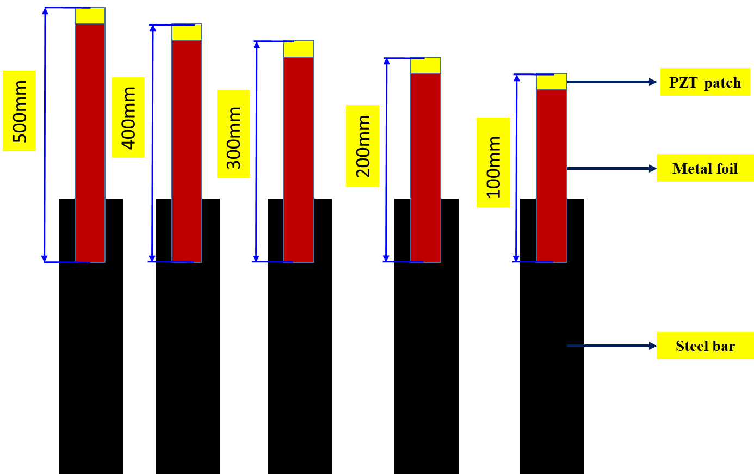

(a) (b) (c) (d) (e)

**Fig.1.** Schematic diagram for different metal foil attached to steel rebar (a) 500mm (b) 400mm (c) 300mm (d) 200mm (e) 100mm

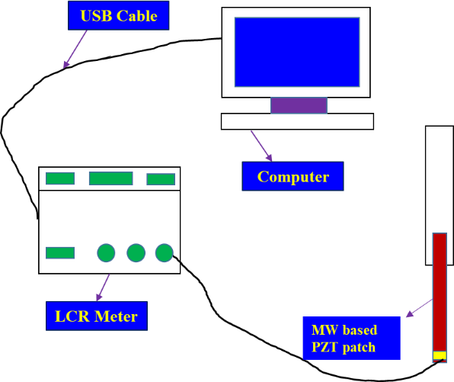

**Fig.2.** Schematic diagram for metal foil-based EMI measurement system

Results and discussions

3.1 Sensor stabilization

Infrastructure systems can deteriorate over time, affects their reliability and lifespan. Pre-installed sensor’s signal stabilization is crucial to ensuring consistent performance in such situations. The stability of the sensors is essential for the measurement of EMI signals because of baseline approach for damage quantification. Sensor stabilization is a critical aspect of maintaining infrastructure systems and ensuring their optimal performance. As sensors are sensitive to external factors such as temperature, humidity, and noise, the electrical signal attenuation changes very rapidly, hence the inaccurate sensing can lead to inaccurate measurement of the EMI signals.

Therefore, it is necessary to stabilize the sensors to minimize the effects of external factors and ensure that the impedance of the sensors remains constant throughout the measurement process. To achieve baseline signatures required for the EMI technique, sensor stabilization of a metal foil-based Configuration of steel samples is necessary. In this study, the researchers wish to investigate the suitability of non-bonded Configuration PZT patch i.e., Metal Foil Based Piezo Sensor (MFBPS) for ensuring it’s repeatability and reproducibility as par with surface bonded Configuration. Also variation length of metal wire and it’s effect on overall piezo coupled admittance signature also studied in this paper. The three lab-sized reinforced steel bar equipped with metal foil based PZT patches were utilized to acquire conductance signatures for a specific time period, ensuring sensor readings and good repeatability. The healthy signatures were obtained for five different length i.e, 100mm,200mm,300mm,400mm and 500mm; ranging from 30-300 kHz frequency, at 27°C. This was done without imposing any structural load on steel. Fig.3 (a)-(e) shows repeatability of the signatures of Metal Foil Based Piezo Sensor (MFBPS) for 100mm,200mm,300mm,400mm and 500mm respectively. It shows a consistent pattern, indicating that the bonding process is stable and reliable, very crucial indicator for the performance and longevity of the PZT sensor.

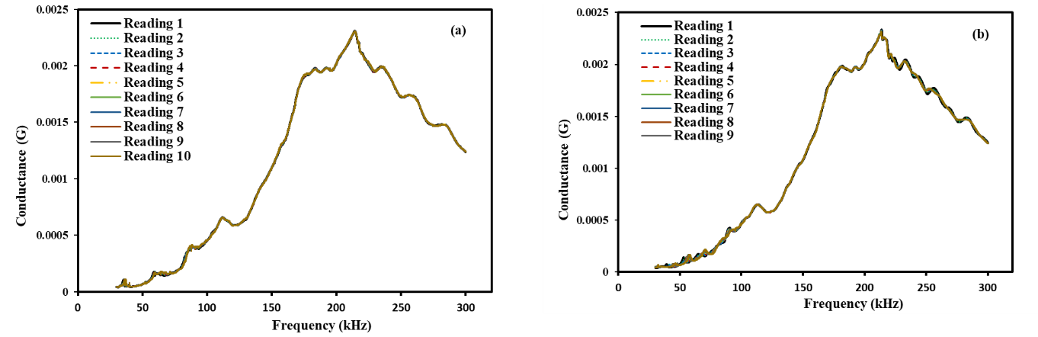

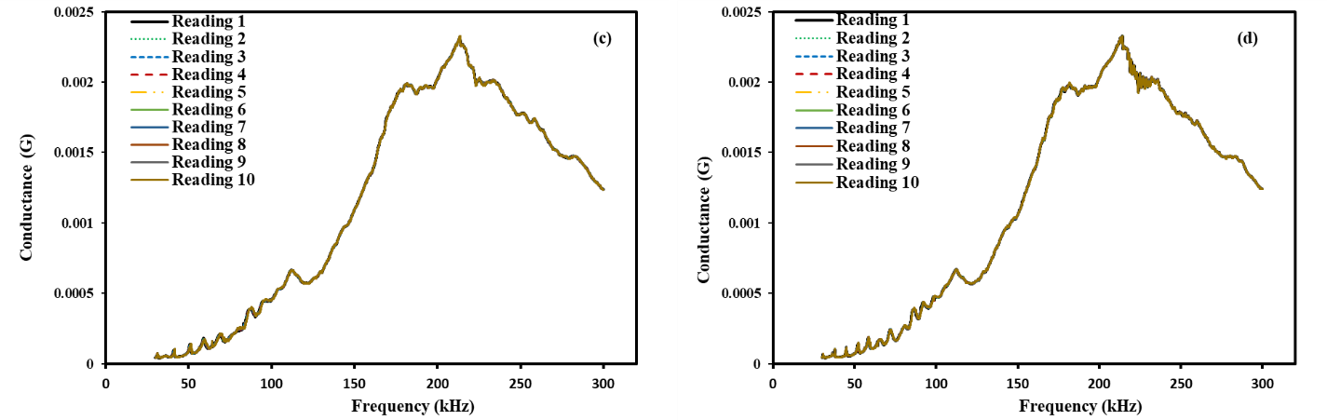

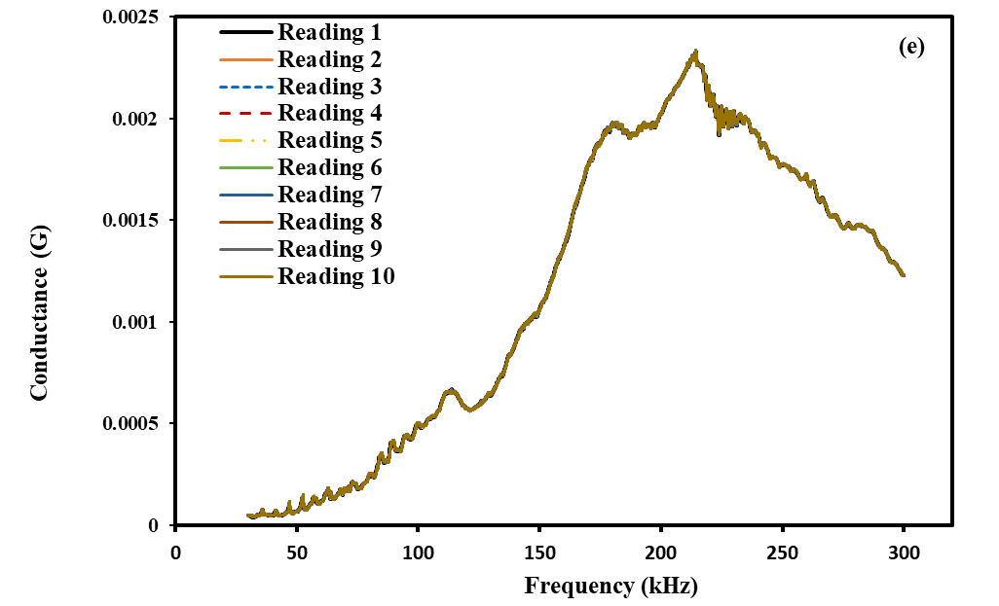

**Fig.3.** Conductance vs. frequency for Metal foil lengths of (a) 100mm (b) 200mm (c) 300mm (d) 400mm (e) 500mm

3.2 Statistical indices

In impedance based SHM, for damage quantification, many statistical indices is being used i.e., RMSD,MAPD, and CCDM. The correlation coefficient deviation metric (CCDM) [28] is commonly used to evaluate the change in signal measurement due to any structural anomaly or any electrical fluctuation. The CCDM index for the piezo-coupled signatures can be expressed as

$CCDM=1-\frac{cov [Re\left(G_{j}^{1}\right){,Re(G}_{j}^{i})]}{σ_{1}σ_{2}}$ (1)

where cov is the covariance between the $G_{j}^{1}$ and $G_{j}^{2}$. $σ_{1}{and σ}_{2}$ standard deviations of each signature. This metric assesses the level of concordance between the measurements.

Fig.4. shows the CCDM index variation for various metal foil lengths i.e., 100mm, 200mm, 300mm, 400mm, and 500mm. For every length, after having repetitive signature, CCDM indices were plot and shown in Fig. 4 to study the preliminary variation between them. As it is observed from Fig. 4 the variation between reading for each length and every length, there is no significant change in values, mostly are constant. Through closer inspection, it can be seen that the 500mm metal foil length exhibits superior stabilization of CCDM values compared to the other foil lengths. While other foil lengths display better repeatability of signatures, the 500mm metal foil length demonstrates better stabilization of admittance signatures and can be employed in complex infrastructures.

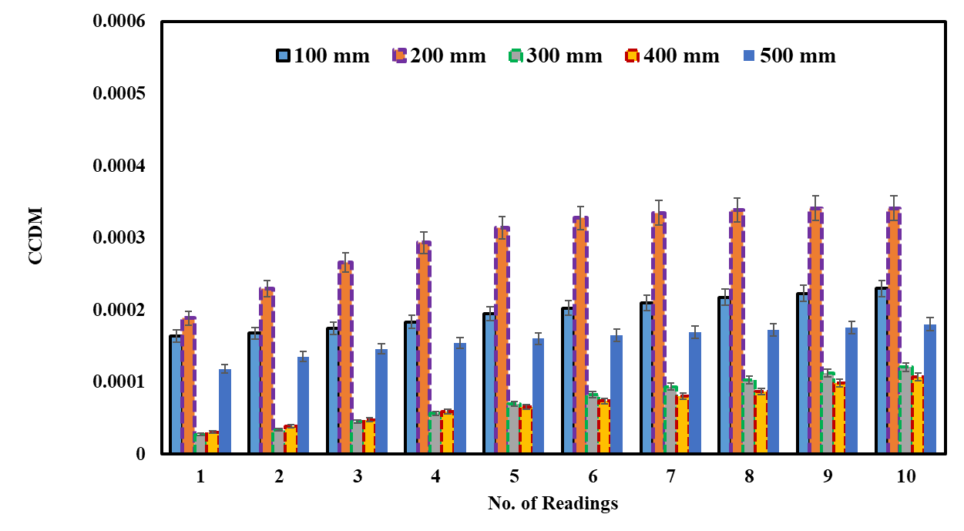

**Fig.4.** Statistical variations at different metal foil length

3.3 Repeatability and reproducibility (R &R) Techniques

This section covers proposed R&R techniques for the repetitive EMI signal measured through impedance signature. This approach allowed for a more comprehensive understanding of the factors contributing to the variation in the results. In any system, the variability present can be attributed to two main factors: the inherent variability of the underlying process and the variability of the measurement system used to evaluate it, is illustrated in equation 2.

$σ_{Total}^{2}=σ_{Process}^{2}+σ_{Measurement}^{2}$ (2)

The verification of the measurement system is an essential step in determining the true variability of a process under investigation. This verification process helps to identify and eliminate any sources of measurement error, thus providing accurate and precise data for further analysis [40,41]. Reproducibility and repeatability are the two key elements that contribute to the measurement system variance is outlined in equation 3.

$σ_{Measurement}^{2}=σ_{Repeatability}^{2}+σ_{Reproducibility}^{2}$ (3)

Assessing the accuracy and precision of measurement processes requires careful consideration of two essential parameters - repeatability and reproducibility. Repeatability can be evaluated by measuring the same part multiple times with the same measurement device and recording the results. This practice enables the operator to assess the consistency of the measurements, making it a vital aspect of quality control in any measurement process. The variance of these measurements represents the degree of repeatability. To ensure reproducibility, it is necessary to have multiple operators measure the same part using the same measurement device. This enables the calculation of an average based on the measurements taken by different individuals [42,43]. The range method, average and range method, and analysis of variance method are the three main techniques for performing Gauge R&R. The range and average range technique approximates measurement variability but does not compute repeatability and reproducibility of the measurement equipment individually. The widely used and precise analysis of variance (ANOVA) approach is used to determine the repeatability and reproducibility of a measuring system. Additionally, it measures the variability of how the parts and the operator interact.

Repeatability and reproducibility measures are essential for evaluating the reliability of the results obtained from a model of analysis of variance (ANOVA). Here the author used CCDM index to study the repeatability and reproducibility measures for different metal wire lengths. Variance based ANOVA analysis was carried out using CCDM metrics from each foil length with 20 repetitions using MINITAB software. This analysis helps to study the efficiency and capability of metal foil based PZT patches. The study considers a randomized design with two factors i.e., two operators and five parts/metal foil length with 20 repetitions on each length. In the analysis of the variability of the CCDM metric, the authors utilized the analysis of variance technique to estimate the respective percentages of contribution variance, study variance and NDC in relation to the total variation of the data (See Table 1). The Automotive Industry Action Group (AIAG) [38] has provided the guidelines for assessing measurement systems using % contribution variance, study variance and NDC (see Table 2).

It can be observed that the contribution % of overall R&R values is lower in the case of 500mm metal foil length i.e. 0.13. This indicates that the 500mm length possesses an acceptable measurement system for variance analysis. Typically, experiments yield better outcomes when R&R values are lower [39]. Moreover, 200mm and 400mm metal foil length shows acceptable measurement system, but the % contribution variance is lower in 500mm. It has been found from the research, a suitable measurement system that meets the AIAG group guidelines, requires less than 10% variance. On this account, the study variance found to be only 3.54% for a 500mm metal foil length. While both 200mm and 400mm metal foil lengths meets the AIAG guidelines for an adequate measuring system, but the variance is much lower for the 500mm length, making it more suitable for impedance signal measurements. On the other hand, 100mm and 300mm metal foil lengths have unacceptable variance contributions and require improvement. The NDC for the 500mm length is higher, indicating an acceptable measuring system compared to other metal foil lengths [39]. However, the NDC value is 1 for the 300mm length, indicating an inadequate measurement system.

**Table 1.** CCDM metrics of estimated variance contribution percentages to the total variation in the R&R study

|  |  |  |  |
| --- | --- | --- | --- |
| **MW length** | **Total gage R&R** | |  |
| **% Contribution variance** | **%Study variance** | **NDC** |
| 100mm | 1.92 | 13.87 | 10 |
| 200mm | 0.40 | 6.36 | 22 |
| 300mm | 39.93 | 63.19 | 1 |
| 400mm | 0.83 | 9.11 | 15 |
| 500mm | 0.13 | 3.54 | 39 |

**Table 2.** Automotive Industry Action Group (AIAG) guidelines [38]

|  |  |  |  |
| --- | --- | --- | --- |
| **Source** | **Decision rule** | | |
| **Adequate measuring system** | **Acceptable based on application, cost of repair and device, other factors** | **Unacceptable and should be improved** |
| % contribution variance | <1% | >=1% &<=9% | >9% |
| % Study variance | <10% | >=10% &<=30% | >30% |
| Number of Distinct Categories (NDC) | >=5 |  | <5 |

Fig.5. shows the component variations of CCDM metrics for different metal foil lengths. It has been seen that larger variance caused by the measurement system indicates an adequate measuring system in case of 500mm metal foil length. A reliable measurement system should have a smaller variance caused by the measurement system when compared to the variance between individual parts. If the part-part variations, bars in the column are high, it indicates a stable piezo-signal measurement system.

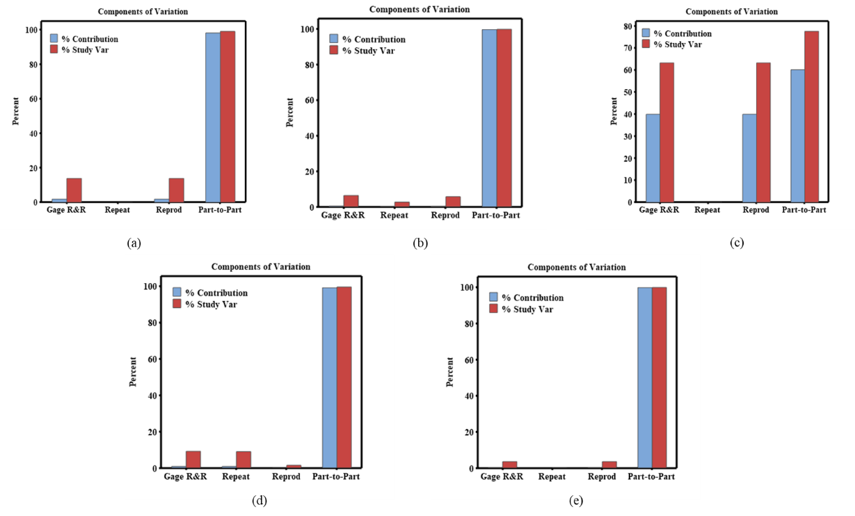

**Fig.5.** Components of variations at different metal foil length (a) 100mm (b) 200mm (c) 300mm (d) 400mm (e) 500mm

Fig. 6. shows the variations of CCDM by parts for different length of metal foils. This study presents the findings of the measurements and averages obtained for each part. The goal is to have the data collected for each part overlap in the chart. However, Figure 6 shows the measurement variance of the parts remains consistent for a metal foil length of 500mm. Moreover, in the case of other metal foil Configurations the results were inconsistent. These findings suggest that further investigation is needed to identify the sources of measurement error and to improve the accuracy and reliability of the measurements in case of 100mm,200mm,300mm,400mm length.

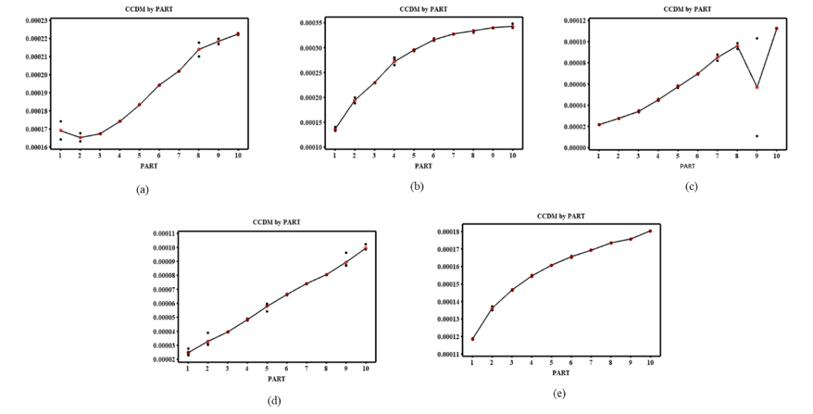

**Fig.6.** Variations of CCDM by parts at different metal foil length (a) 100mm (b) 200mm (c) 300mm (d) 400mm (e) 500mm

Fig.7. indicates the $\overline{x}$ chart of the operators to know the results of the variance due to metal foil length or the measurement process itself. From this chart, for the best experimental design and it’s outcome, the higher variance in the piezo signal Configuration in not acceptable but rather the process (hence the frequency sweep calibration, i.e., LCR meter) itself should be the cause faulty results and robust measuring system. Measurements being within control limits (i.e. UCL and LCL) shows that an incorrect or faulty measurement system was employed. In Fig. 7, the mean chart shows the acceptable measuring system in case of 500mm metal foil length. The variation in variance is caused due to measurement of metal foil length.

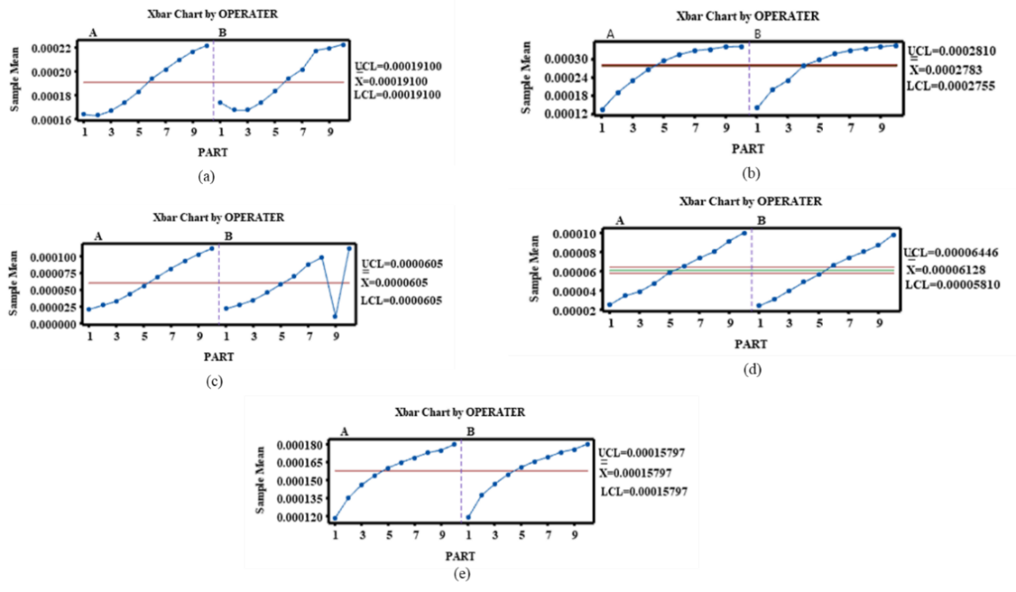

**Fig.7.** Mean chart by operator at different metal foil length (a) 100mm (b) 200mm (c) 300mm (d) 400mm (e) 500mm

Conclusion

This paper comprises repeatability & reproducibility study of different metal foil length based PZT attached to construction steel rebar. In this study, we investigated the repeatability and reproducibility measures for different aluminum foil length-based electro-mechanical impedance techniques. The aim was to demonstrate a statistical proof of concept for the effectiveness, and reliability of the piezo configuration in realistic structural applications. Through the experimental results and statistical investigation, it is found that the sensor stabilization and signal repeatability of 500mm length metal foil performs better than 100mm,200mm,300mm & 400mm. For 500mm metal foil length, the gauge R&R study shows very promising results with greater accuracy. In total gauge R & R study, the parametric variation of sensor (for non-bonded and reusable) length has shown equal accuracy towards regular bonding process (i.e., surface bonded). The length variation of metal is significant for non-contact based sensor integrated SHM, where complex structural geometry becomes a constraint for infrastructure health management. With repetitive measurement, the piezo coupled signature acquired with operator and one equipment. the measurement system the variance are categorially evaluated for statistical matrix CCDM, derived from piezo driven signals. From ANOVA based study, the measurement variances i.e, % contribution of study part (i.e. length of metal wire) and contribution variance (i.e. piezo driven signal attached to metal with varying length) towards the potential evaluation and usage for reusable and non-bonded configuration of sensor for PISHM. In overall, this study demonstrates the potential of aluminum foil length-based electro-mechanical impedance techniques as a reliable and effective tool for monitoring complex infrastructures. The proposed can add to the continuing research in SHM and provides insights for the development of reliable and efficient EMI sensors for practical applications where it's not feasible to place PZT patches directly to the host structure.

**Author Contributions:** Conceptualization, methodology, formal analysis, data curation, writing— original draft preparation, validation, resources, visualization, L.P.; Data curation, visualization, S.S.; writing—review and editing, supervision, visualization, S.M.; G.A.; funding acquisition, G.A.; S.M; All authors have read and agreed to the published version of the manuscript.

**Funding:** This research received no external funding.

**Institutional Review Board Statement:** Not applicable.

**Informed Consent Statement:** Not applicable.

**Data Availability Statement:** Not applicable.

**Conflicts of Interest:** The authors declare no conflict of interest.

**References**

1. Pan, Y., Zhang, Y., Zhang, D. and Song, Y., 2021. 3D printing in construction: state of the art and applications. The International Journal of Advanced Manufacturing Technology, 115(5-6), pp.1329-1348. DOI: https://doi.org/10.1007/s00170-021-07213-0
2. Tahmasebinia, F.; Niemelä, M.; Ebrahimzadeh Sepasgozar, S.M.; Lai, T.Y.; Su, W.; Reddy, K.R.; Shirowzhan, S.; Sepasgozar, S.; Marroquin, F.A. Three-Dimensional Printing Using Recycled High-Density Polyethylene: Technological Challenges and Future Directions for Construction. Buildings 2018, 8, 165. DOI: <https://doi.org/10.3390/buildings8110165>
3. Sobotka, A., & Pacewicz, K. (2017, October). Mechanisation and automation technologies development in work at construction sites. In IOP Conference Series: Materials Science and Engineering (Vol. 251, No. 1, p. 012046). IOP Publishing. DOI: 10.1088/1757-899X/251/1/012046
4. Gosselin, C., Duballet, R., Roux, P., Gaudillière, N., Dirrenberger, J. and Morel, P., 2016. Large-scale 3D printing of ultra-high performance concrete–a new processing route for architects and builders. Materials & Design, 100, pp.102-109. DOI: <https://doi.org/10.1016/j.matdes.2016.03.097>
5. Makul, N., 2020. Advanced smart concrete-A review of current progress, benefits and challenges. Journal of Cleaner Production, 274, p.122899. DOI: <https://doi.org/10.1016/j.jclepro.2020.122899>
6. Hamidi F, Aslani F. Additive manufacturing of cementitious composites: materials, methods, potentials, and challenges. Constr Build Mater. 2019;218:582–609. DOI: <https://doi.org/10.1016/j.conbuildmat.2019.05.140>
7. El-Sayegh, S., Romdhane, L. & Manjikian, S. A critical review of 3D printing in construction: benefits, challenges, and risks. Archiv.Civ.Mech.Eng 20, 34 (2020). DOI: <https://doi.org/10.1007/s43452-020-00038-w>
8. Labonnote, N., Rønnquist, A., Manum, B. and Rüther, P., 2016. Additive construction: State-of-the-art, challenges and opportunities. Automation in construction, 72, pp.347-366. DOI: <https://doi.org/10.1016/j.autcon.2016.08.026>
9. Paolini, A., Kollmannsberger, S. and Rank, E., 2019. Additive manufacturing in construction: A review on processes, applications, and digital planning methods. Additive manufacturing, 30, p.100894. DOI: <https://doi.org/10.1016/j.addma.2019.100894>
10. ASTM Standard. Standard Terminology for Additive Manufacturing Technologies; Astm International: West Conshohocken, PA, USA,2012.
11. Bos, F., Wolfs, R., Ahmed, Z. and Salet, T., 2016. Additive manufacturing of concrete in construction: potentials and challenges of 3D concrete printing. Virtual and physical prototyping, 11(3), pp.209-225. DOI: https://doi.org/10.1080/17452759.2016.1209867
12. Maqbool, R., Saiba, M.R. & Ashfaq, S. Emerging industry 4.0 and Internet of Things (IoT) technologies in the Ghanaian construction industry: sustainability, implementation challenges, and benefits. Environ Sci Pollut Res (2022). DOI: <https://doi.org/10.1007/s11356-022-24764-1>
13. Tang, S., Shelden, D.R., Eastman, C.M., Pishdad-Bozorgi, P. and Gao, X., 2019. A review of building information modeling (BIM) and the internet of things (IoT) devices integration: Present status and future trends. Automation in Construction, 101, pp.127-139. DOI: <https://doi.org/10.1016/j.autcon.2019.01.020>
14. Iqbal, N. and Kim, D.H., 2022. Iot task management mechanism based on predictive optimization for efficient energy consumption in smart residential buildings. Energy and Buildings, 257, p.111762. DOI: <https://doi.org/10.1016/j.enbuild.2021.111762>
15. Ma, N., Waegel, A., Hakkarainen, M., Braham, W.W., Glass, L. and Aviv, D., 2023. Blockchain+ IoT sensor network to measure, evaluate and incentivize personal environmental accounting and efficient energy use in indoor spaces. Applied Energy, 332, p.120443. DOI: <https://doi.org/10.1016/j.apenergy.2022.120443>
16. Hassan, C.A.U.; Iqbal, J.; Khan, M.S.; Hussain, S.; Akhunzada, A.; Ali, M.; Gani, A.; Uddin, M.; Ullah, S.S. Design and Implementation of Real-Time Kitchen Monitoring and Automation System Based on Internet of Things. Energies 2022, 15, 6778. <https://doi.org/10.3390/en15186778>
17. Ji, Y.; Wang, W.; Zheng, M.; Chen, S. Real Time Building Evacuation Modeling with an Improved Cellular Automata Method and Corresponding IoT System Implementation. Buildings 2022, 12, 718. <https://doi.org/10.3390/buildings12060718>
18. Franchi, F.; Marotta, A.; Rinaldi, C.; Graziosi, F.; Fratocchi, L.; Parisse, M. What Can 5G Do for Public Safety? Structural Health Monitoring and Earthquake Early Warning Scenarios. Sensors 2022, 22, 3020. <https://doi.org/10.3390/s22083020>
19. Ghosh, A., Edwards, D.J. and Hosseini, M.R. (2021), "Patterns and trends in Internet of Things (IoT) research: future applications in the construction industry", Engineering, Construction and Architectural Management, Vol. 28 No. 2, pp. 457-481. DOI: <https://doi.org/10.1108/ECAM-04-2020-0271>
20. Yang, R., Wakefield, R., Lyu, S., Jayasuriya, S., Han, F., Yi, X., Yang, X., Amarasinghe, G. and Chen, S., 2020. Public and private blockchain in construction business process and information integration. Automation in construction, 118, p.103276. DOI: <https://doi.org/10.1016/j.autcon.2020.103276>
21. Rao, A.S., Radanovic, M., Liu, Y., Hu, S., Fang, Y., Khoshelham, K., Palaniswami, M. and Ngo, T., 2022. Real-time monitoring of construction sites: Sensors, methods, and applications. Automation in Construction, 136, p.104099. DOI: <https://doi.org/10.1016/j.autcon.2021.104099>
22. Zhang, M.; Cao, T.; Zhao, X. Applying Sensor-Based Technology to Improve Construction Safety Management. Sensors 2017, 17, 1841. DOI: <https://doi.org/10.3390/s17081841>
23. Liang, C., Sun, F.P. and Rogers, C.A., 1997. Coupled electro-mechanical analysis of adaptive material systems-determination of the actuator power consumption and system energy transfer. Journal of intelligent material systems and structures, 8(4), pp.335-343. DOI: https://doi.org/10.1177/1045389X9700800406
24. Ma, G., Li, Y., Wang, L., Zhang, J. and Li, Z., 2020. Real-time quantification of fresh and hardened mechanical property for 3D printing material by intellectualization with piezoelectric transducers. Construction and Building Materials, 241, p.117982. DOI: <https://doi.org/10.1016/j.conbuildmat.2019.117982>
25. Li, G., Luo, M., Huang, J. and Li, W., 2023. Early-age concrete strength monitoring using smart aggregate based on electromechanical impedance and machine learning. Mechanical Systems and Signal Processing, 186, p.109865. DOI: <https://doi.org/10.1016/j.ymssp.2022.109865>
26. Lim, Y.Y. and Soh, C.K., 2011. Fatigue life estimation of a 1D aluminum beam under mode-I loading using the electromechanical impedance technique. Smart Materials and Structures, 20(12), p.125001. DOI: 10.1088/0964-1726/20/12/125001
27. Na, S. and Lee, H.K., 2013. Neural network approach for damaged area location prediction of a composite plate using electromechanical impedance technique. Composites Science and Technology, 88, pp.62-68. DOI: <https://doi.org/10.1016/j.compscitech.2013.08.019>
28. Parida, L.; Moharana, S.; Ferreira, V.M.; Giri, S.K.; Ascensão, G. A Novel CNN-LSTM Hybrid Model for Prediction of Electro-Mechanical Impedance Signal Based Bond Strength Monitoring. Sensors 2022, 22, 9920. DOI: <https://doi.org/10.3390/s22249920>
29. Parida, L. and Moharana, S., 2022. Monitoring Loading Effects of Construction Steel Structure Using Piezo Transducer for Electromechanical Impedance Techniques. In Recent Advances in Materials, Mechanics and Structures: Select Proceedings of ICMMS 2022 (pp. 371-380). Singapore: Springer Nature Singapore. DOI: <https://doi.org/10.1007/978-981-19-3371-4_33>
30. Banerjee, T., Parida, L. and Moharana, S., 2019, December. Monitoring and Diagnosis of Thermal Expansion of Rails and Rail Joints Using Piezoelectric Sensor for Electro-Mechanical Impedance Technique. In Proceedings of the NDE 2019 Conference & Exhibition, Bengaluru, India (pp. 5-7).
31. Moharana, S., 2021. Investigation of a continuum shear lag model as an indicator for the damage detection in Piezo-Elasto dynamic structure. Journal of Vibration Engineering & Technologies, 9(7), pp.1755-1768. DOI: <https://doi.org/10.1007/s42417-021-00326-6>
32. Na, S. and Lee, H.K., 2013. Steel wire electromechanical impedance method using a piezoelectric material for composite structures with complex surfaces. Composite Structures, 98, pp.79-84. DOI: <https://doi.org/10.1016/j.compstruct.2012.10.046>
33. Naskar, S. and Bhalla, S., 2016. Metal-wire-based twin one-dimensional orthogonal array Configuration of PZT patches for damage assessment of two-dimensional structures. Journal of Intelligent Material Systems and Structures, 27(11), pp.1440-1460. DOI: <https://doi.org/10.1177/1045389X15592480>
34. Khante, S.N. and Jain, N., 2019. Erosion identification and assessment of a steel pipeline using EMI technique. In Green Buildings and Sustainable Engineering: Proceedings of GBSE 2018 (pp. 347-355). Springer Singapore. DOI: <https://doi.org/10.1007/978-981-13-1202-1_30>
35. Borror, C.M., Montgomery, D.C. and Runger, G.C., 1997. Confidence intervals for variance components from gauge capability studies. Quality and Reliability Engineering International, 13(6), pp.361-369. DOI: [https://doi.org/10.1002/(SICI)1099-1638(199711/12)13:6<361::AID-QRE126>3.0.CO;2-2](https://doi.org/10.1002/(SICI)1099-1638(199711/12)13:6%3c361::AID-QRE126%3e3.0.CO;2-2)
36. Veit, E., 2003. O controle estatístico de processos na indústria de cabinagem de veículos: um estudo de caso.
37. Nomelini, Q.S.S., 2012. Enfoque estatístico na validação de métodos para teste de germinação de sementes florestais.
38. AIAG. (2010). Preparation for a Measurement System Study MSA (fourth edition ed.). Automotive Industry Action Group.
39. Airbus. (2011). Measurement system analysis Gage R&R. EU: AIRBUS S.A.S.
40. Aized, T. ed., 2012. Total quality management and six sigma. BoD–Books on Demand.
41. Gerger, A., & Firuzan, A. R. (2020). Taguchi based Case study in the automotive industry: nonconformity decreasing with use of Six Sigma methodology. Journal of Applied Statistics. DOI:https://doi.org/10.1080/02664763.2020.1837086
42. Hwang, L.T. and Horng, T.S.J., 2018. 3D IC and RF SiPs: Advanced Stacking and Planar Solutions for 5G Mobility. John Wiley & Sons.
43. Weaver, B.P., Hamada, M.S., Vardeman, S.B. and Wilson, A.G., 2012. A Bayesian approach to measurement system assessment. Quality Engineering, 24(4), pp.486-500. DOI:10.1080/08982112.2012.702381